**Batch: A1 Roll No.: 16010123012**

**Experiment / assignment / tutorial No. 1**

**Grade: AA / AB / BB / BC / CC / CD /DD**

**Signature of the Staff In-charge with date**

|  |
| --- |
| **Title: :** Implementation of Database in SQL -DDL |

**Objective:** Define/modify database definitions with proper constraints

_____________________________________________________________

**Expected Outcome of Experiment:**

CO 2: Convert entity-relationship diagrams into relational tables, populate a relational

database and formulate SQL queries on the data Use SQL for creation and query the database.

CO 3: Define and apply integrity constraints and improve database design using normalization techniques.

_______________________________________________________________________

**Pre Lab/ Prior Concepts**:

Resources used: Postgresql

**Theory:** The set of relations in a database must be specifies to the system by means of a data definition language (DDL). The SQL DDL allows specification of not only a set of relations but also specific information about the relation including,

1. The schema for each relation
2. The domain of values associated with each attribute
3. The integrity constraints
4. The set of indices to be maintained for each relation
5. The security and authorization information for each relation
6. The physical storage structure of each relation on disk

**Syntax Create Table:**

create table employee(ssn,fname varchar(10), mname varchar(10), lname varchar(10), desg varchar(20), gender varchar(5), addr varchar(20), bdate datetime, sal float,primary key(ssn));

create table manages(ssn int, dept_code int, start_dt datetime, foreign key(ssn) references employee, foreign key(dept_code) references department, key(ssn,dept_code) ) on delete set null

**Data Constraints**

Business managers of the organization determine a set of rules that must be applied before the data is stored in the database. The application of such rules on raw data ensures **data integrity**.

**Eg:-** An employee belonging to the Sales department cannot have a salary higher than Rs. 1000.

An employee has an unique identification number.

**Applying Data Constraints**

Oracle permits data constraints to be attached to table columns using SQL syntax. Constraints can be attached to table columns using Alter table.

**Unique Constraint**

**Unique Constraint- At column level Syntax**

**<ColumnName><Datatype>(<size>) UNIQUE**

**Unique Constraint- At table level**

**CREATE TABLE<TableName>(**

**<ColumnName><Datatype>(<size>)**

**<ColumnName><Datatype>(<size>)**

**<Columnname><Datatype>(<size>) UNIQUE(<ColumnName1>,<ColumnName2>);**

**Implementation Details (Problem Statement, Query and Screenshots of Results):**

CREATE TABLE EMPLOYEE (  
    Fname VARCHAR(50),  
    Minit CHAR(1),  
    Lname VARCHAR(50),  
    Ssn CHAR(9) PRIMARY KEY,  
    Bdate DATE,  
    Address VARCHAR(100),  
    Sex CHAR(1),  
    Salary DECIMAL(10, 2),  
    Super_ssn CHAR(9),  
    Dno INT,  
    FOREIGN KEY (Super_ssn) REFERENCES EMPLOYEE(Ssn)  
);

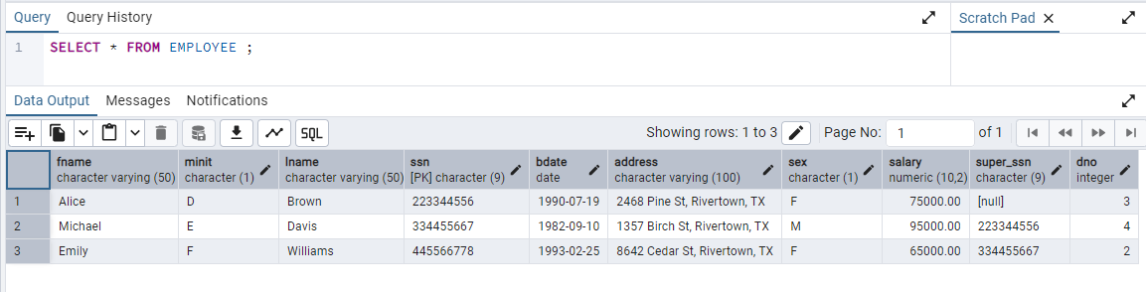

CREATE TABLE DEPARTMENT (  
    Dname VARCHAR(50),  
    Dnumber INT PRIMARY KEY,  
    Mgr_ssn CHAR(9),  
    Mgr_start_date DATE,  
    FOREIGN KEY (Mgr_ssn) REFERENCES EMPLOYEE(Ssn)  
);  
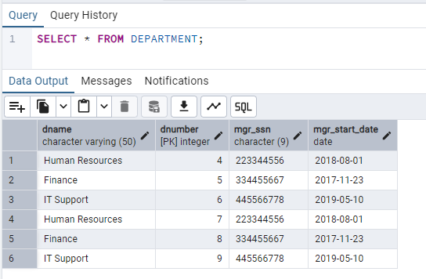

CREATE TABLE DEPT_LOCATIONS (  
    Dnumber INT,  
    Dlocation VARCHAR(50),  
    PRIMARY KEY (Dnumber, Dlocation),  
    FOREIGN KEY (Dnumber) REFERENCES DEPARTMENT(Dnumber)  
);

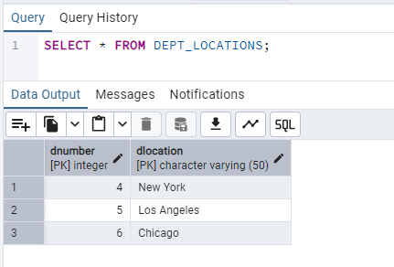

CREATE TABLE PROJECT (  
    Pname VARCHAR(50),  
    Pnumber INT PRIMARY KEY,  
    Plocation VARCHAR(50),  
    Dnum INT,  
    FOREIGN KEY (Dnum) REFERENCES DEPARTMENT(Dnumber)  
);

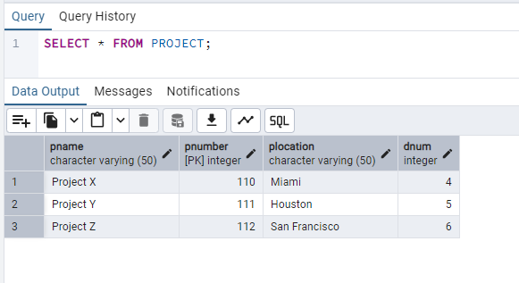

CREATE TABLE WORKS_ON (  
    Essn CHAR(9),  
    Pno INT,  
    Hours DECIMAL(5, 2),  
    PRIMARY KEY (Essn, Pno),  
    FOREIGN KEY (Essn) REFERENCES EMPLOYEE(Ssn),  
    FOREIGN KEY (Pno) REFERENCES PROJECT(Pnumber)  
);

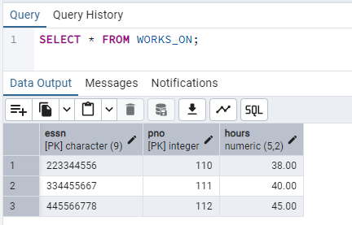

CREATE TABLE DEPENDENT (  
    Essn CHAR(9),  
    Dependent_name VARCHAR(50),  
    Sex CHAR(1),  
    Bdate DATE,  
    Relationship VARCHAR(50),  
    PRIMARY KEY (Essn, Dependent_name),  
    FOREIGN KEY (Essn) REFERENCES EMPLOYEE(Ssn)  
);

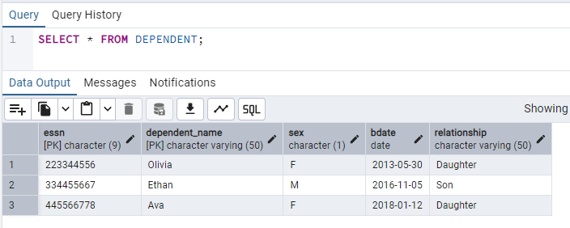  
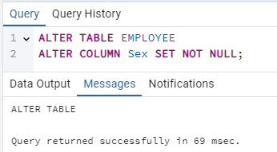

**Post Lab Questions:**

1. **Explain in brief the following terms:**

**a. Database**A database is an organized collection of data, typically stored and accessed electronically from a computer system. It can store information in tables, and these tables are designed to handle different types of data like numbers, text, or dates.

**b. Types of databases  
Relational Database**: Stores data in tables with rows and columns (e.g., MySQL, PostgreSQL, Oracle).  
**NoSQL Database**: A non-tabular database that stores data in a variety of formats like documents, key-value pairs, or graphs (e.g., MongoDB, Cassandra).  
**In-memory Database**: Stores data in the system's RAM for faster access (e.g., Redis).

**c. SQL Data Types**

**INT**: Integer values.

**VARCHAR**: Variable-length strings of characters.

**DATE**: Stores date values.

**FLOAT**: Stores decimal numbers.

**BOOLEAN**: Stores True or False.

**d. foreignkey**A foreign key is a column (or a set of columns) in one table that uniquely identifies a row of another table. It establishes a relationship between the two tables, ensuring data integrity by enforcing referential constraints.

1. **What are the commands to:**

**a. Delete an entire table -** DROP TABLE table_name;

**b. To view a database -** SHOW DATABASES;  
**c.** **To select & view all the columns -** SELECT * FROM table_name;

1. **For the given ER model and relational model , using DDL commands write syntax to create CREATE Tables with all possible integrity constraints.**

# Problem Statement: A small accounting firm wants a simple HR application that will help it to keep track of its employees, their positions, allowances, salary scales, and which company vehicles their employees drive. The application must keep track of all the positions at the firm, the employees filling these positions, the allowances for these positions, the salary scales for these positions, and the company vehicles assigned to these positions.

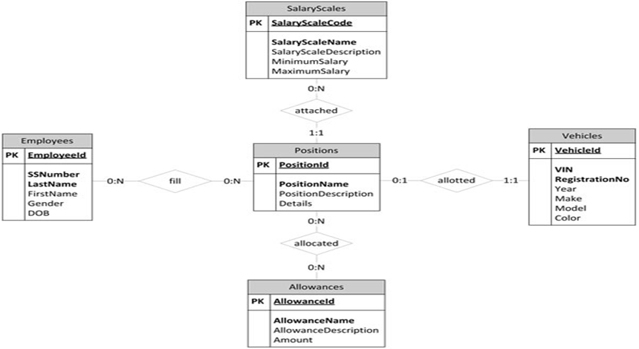

**Conclusion:**

In this experiment, I learned how to insert data into various relational database tables, such as EMPLOYEE, DEPARTMENT, PROJECT, WORKS_ON, and DEPENDENT. I realized the importance of adhering to foreign key and primary key constraints to maintain data integrity. I encountered issues with foreign key violations and duplicate primary key values, which taught me the need for consistency across related tables and unique values for primary keys. Overall, this experiment helped me understand the role of structured data management and error handling in maintaining a reliable database system.